**CHAPTER-11 CLASS ROOM OBJECTIVES**

**CUBES & DICE**

|  |
| --- |
| **PROBLEMS ON DICE** |

**COUNTING THE NUMBER OF CUBES/BLOCKS IN THE GIVEN FIGURE**

**Q1.**Count the number of blocks in the given figure

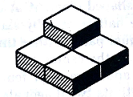

(A) 3 (B) 4 (C) 5 (D) 6

**Q2**. Count the number of blocks in the given figure

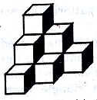

(A) 14 (B) 12 (C) 10 (D) 8

**Q3.**Count the number of blocks in the given figure

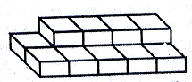

**(A) 10 (B) 14 (C) 18 (D) 20**

**Q4.**Count the number of blocks in the given figure

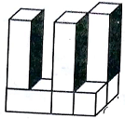

(A) 6 (B) 7 (C) 8 (D) 9

**Q5.** Count the number of cubes in the given figure

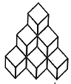

(A) 6 (B) 8 (C) 10 (D) 12

**Q6.** Count the number of cubes in the given figure

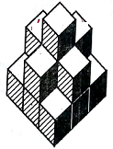

(A) 8 (B) 9 (C) 12 (D) 15

**Q7.** Count the number of cubes in the given figure

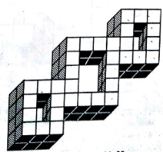

(A) 64 (B) 66 (C) 68 (D) 70

**Q8**. Count the number of cubes in the given figure

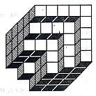

(A) 80 (B) 87 (C) 89 (D) 90

**Q9.** Count the number of cubes in the given figure

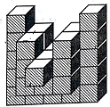

(A) 36 (B) 54 (C) 50 (D) 60

**Q10.**Count the number of cubes in the given figure

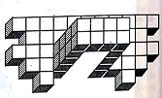

(A) 57 (B) 58 (C) 60 (D) 62

**Q11.**Count the number of cubes in the given figure

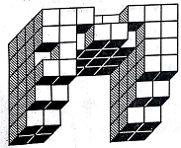

(A) 100 (B) 105 (C) 111 (D) 121

**Q12**. Count the number of cubes in the given figure

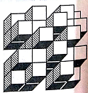

(A) 28 (B) 36 (C) 40 (D) 42

**Q13.**Count the number of cubes in the given figure

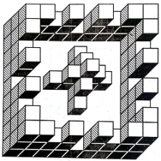

(A) 89 (B) 91 (C) 95 (D) 99

**Q14**. Count the number of cubes in the given figure

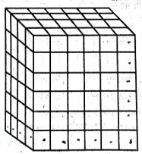

(A) 69 (B) 180 (C) 144 (D) 84

**Q15.** Count the number of cubes in the given figure

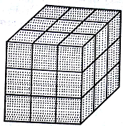

(A) 9 (B) 27 (C) 64 (D) 8

**Q16.** Count the number of cubes in the given figure

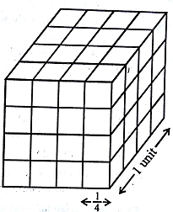

(A) 64 (B) 27 (C) 36 (D) 16

**Q17.** Count the number of cubes in the given figure

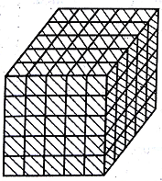

(A) 25 (B) 125 (C) 175 (D) 225

**Directions (question 18 to 23): A cube is painted blue on all faces and is then cut into 125 cubes of equal sizes. Answer the following questions based on this statement.**

**Q18.** How many cubes are not painted on any face?

(A) 8 (B) 16 (C) 27 (D) 36 (E) 54

**Q19.** How many cubes are painted on one face only?

(A) 16 (B) 32 (C) 48 (D) 54 (E) 72

**Q20.** How many cubes are painted on two face only?

(A) 8 (B) 16 (C) 22 (D) 44 (E) None

**Q21.** How many cubes are painted on three face only?

(A) 16 (B) 10 (C) 18 (D) 12 (E) 8

**Q22**. How many cubes are painted on four face only?

(A) 8 (B) 4 (C) 2 (D) 0

**Q23**. How many cubes are painted on two six only?

(A) 8 (B) 4 (C) 1 (D) 0

**Directions (question 24 to 33): A solid cube of each side 8cm, has been painted red, blue and black on pairs of opposite faces. It is then cut into cubical blacks of each side 2cm.**

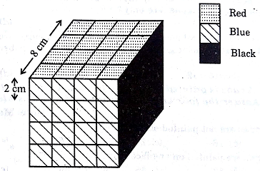

**Q24.** How many cubes have no face painted?

(A) 0 (B) 4 (C) 8 (D) 12

**Q25**. How many cubes are painted on one face only?

(A) 8 (B) 16 (C) 24 (D) 28

**Q26**. How many cubes are painted on two faces only?

(A) 8 (B) 16 (C) 20 (D) 24

**Q27.**How many cubes are painted on three faces only?

(A) 0 (B) 4 (C) 6 (D) 8

**Q28**. How many cubes are painted on three faces with different colours?

(A) 0 (B) 4 (C) 8 (D) 12

**Q29**How many cubes have two faces painted red and black and all other faces unpainted?

(A) 4 (B) 8 (C) 16 (D) 32

**Q30**. How many cubes have one face painted red and all other faces unpainted?

(A) 4 (B) 8 (C) 12 (D) 16

**Q31**. How many cubes have two faces painted black?

(A) 2 (B) 4 (C) 8 (D) None

**Q32**. How many cubes have one face painted blue and one face painted red? (The other faces may be painted or unpainted)

(A) 32 (B) 16 (C) 10 (D) 8

**Q33**. How many cubes are there in all?

(A) 64 (B) 48 (C) 32 (D) 16

**Directions (question 34 to 38): A wooden cube is painted Blue on all the four adjoining sides and Green on two opposite sides i.e. top and bottom. It is then cut at equal distances at right angles four time vertically (top to bottom) and two times horizontally (along the sides) as shown in figure, where the dotted lines represent the cuts mode. Study the diagram and answer the following questions.**

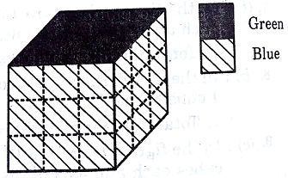

**Q34.** How many cubes have one face painted only in Blue?

(A) 1 (B) 2 (C) 3 (D) 4 (E) 5

**Q35**. How many cubes have one face painted only in Green?

(A) 1 (B) 2 (C) 3 (D) 4 (E) 5

**Q36.**How many cubes are formed in all?

(A) 16 (B) 24 (C) 27 (D) 32 (E) 48

**Q37**. How many cubes will have at least three sides painted?

(A) 12 (B) 8 (C) 6 (D) 3 (E) 2

**Q38**How many cubes will have no face painted at all?

(A) (B) 2 (C) 3 (D) 4 (E) 5

**Q39.** Two positions of a dice are shown below. When 3 is at the bottom, what will be at the top?

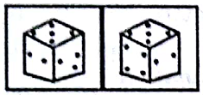

(A) 6 (B) 3 (C) 4 (D) 2

**Q40.**Two positions of a dice are shown below. When one dot is at the bottom, what will be at the top?

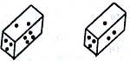

(A) 6 (B) 5 (C) 4 (D) 3

**Q41.** Two positions of a dice are shown below. When 1 is at the bottom, what will be at the top?

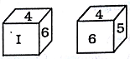

(A) 3 (B) 5 (C) 2 (D) 6

**Q42.** Two positions of a dice are shown below. When 4 is at the bottom, what will be at the top?



(A) 2 (B) 3 (C) 5 (D) 6

**Q43.** Two positions of a dice are shown below. When 5 is at the top, what will be at the bottom?

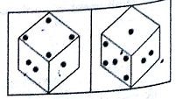

(A) 3 (B) 1 (C) 2 (D) 4

**Q44**. From the following two different appearances of die, find out the colour which is opposite to Red:

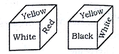

(A) Blue (B) Black (C) White (D) Yellow

**Q45**. From the following two different appearances of die. When the heart shape is at the top what will be at the bottom?

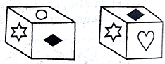

1.  (B)  (C)  (D) 

|  |
| --- |
| **TYPE-3: PROBLEMS ON DICE** |

**Q46**. Four positions of a die is given bellow, identify the number at the bottom when top is 6

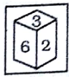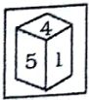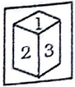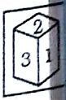

A) 5 B) 1 C) 3 D) 4

**Q47**. Two positions of a dice are shown below. When 3 is at the top, what will be at the bottom?

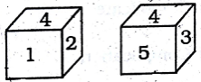

(A) 4 (B) 5 (C) 2 (D) 1

**Q48.** Two positions of a dice are shown below. When 2 is at the top, what will be at the bottom?

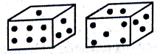

(A) 3 (B) 5 (C) 1 (D) 6

**Q49.** Two positions of a dice are shown below. When 4 is at the top, what will be at the bottom?

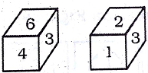

(A) (B) 2 (C) 3 D) 5

**Q50.**Two positions of a dice are shown below. When 2 is at the top, what will be at the bottom?

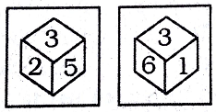

(A) 4 (B) 1 (C) 5 (D) 6

**Q51**. Two positions of a dice are shown below. When 5 is at the top, what will be at the bottom?

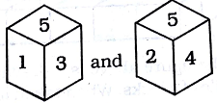

(A) 4 (B) 1 (C) 5 (D) 6

**Q52**. Two positions of a dice are shown below. When A is at the top, what will be at the bottom?

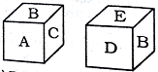

(A) B (B) C (C) D (D) E

**Q53**. The sides of a cube show the colours of rainbow. Two positions of the cube are shown below. Which of the colours of rainbow is left out?

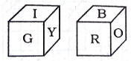

(A) Blue (B) violet (C) Indigo (D) Yellow

**TYPE-4: CONSTRUCTIONS OF BOXES**

**Q54.** When the following figure is folded to form a cube, which number opposite to 3?

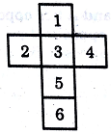

(A) 6 (B) 1 (C) 2 (D) 4

**Q55**. When the following figure is folded to form a cube, which number opposite to 1?

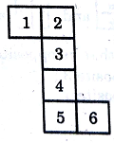

(A) 6 (B) 1 (C) 2 (D) 4

**Q56**. When the following figure is folded to form a cube, which number opposite to 1?

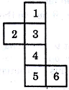

(A) 6 (B) 1 (C) 2 (D) 4

**Q57.** When the following figure is folded to form a cube, which number opposite to 5?

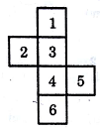

(A) 6 (B) 1 (C) 2 (D) 4

**Q58.** When the following figure is folded to form a cube, which number opposite to  ?

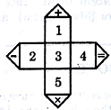

(A) 6 (B) 3 (C) 2 (D) 4

**Q59**. When the following figure is folded to form a cube, which number opposite to 3?

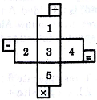

(A)  (B) 5 (C)  (D) 4

**Q60.** Select from the alternatives, the box that can be formed by folding the sheet shown in the figure(X):

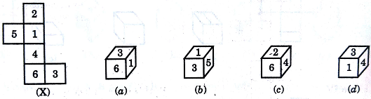

**Q61.** Select from the alternatives, the box that can be formed by folding the sheet shown in the figure(X):

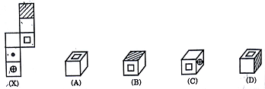

**Q62.** Select from the alternatives, the box that can be formed by folding the sheet shown in the figure(X):

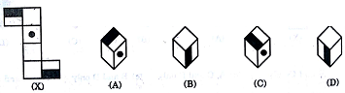

**Q63.** Select from the alternatives, the box that can be formed by folding the sheet shown in the figure(X):

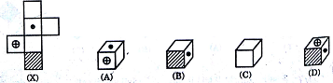

**Q64. .**Select from the alternatives, the box that can be formed by folding the sheet shown in the figure(X):

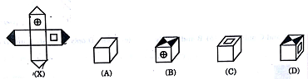

**Q65.** The **six faces of a cube have been marked with numbers 1,2,3,4,5 and 6 respectively. This cube is rolled down three times. The three positions are given in the figures below. Choose the figure that will be formed when the cube is unfolded.**



